How do I embed the player and recorder in my pages (they are a bit different from PTE pages)?
How do I Put my paths from where to play the audio questions and where to save the recorded answer?

Following steps will answer both of the questions above.

dummy.php is the file in which you will embed recorder and audio playback.
dummrecordmp3.js is its API you have to include from mylibs folder
dummyphpuploader.php is the actual uploader which specifies path.

Step 1

The path of file in which you want to use record and playback functionality should be appropriate.
I am using record and playback functionality in 6 files below:-
- Intro.php
- Readaloud.php
- Repeatsentence.php
- Imagespeak.php
- Retelllecture.php
- Shortanswer.php

For example:-

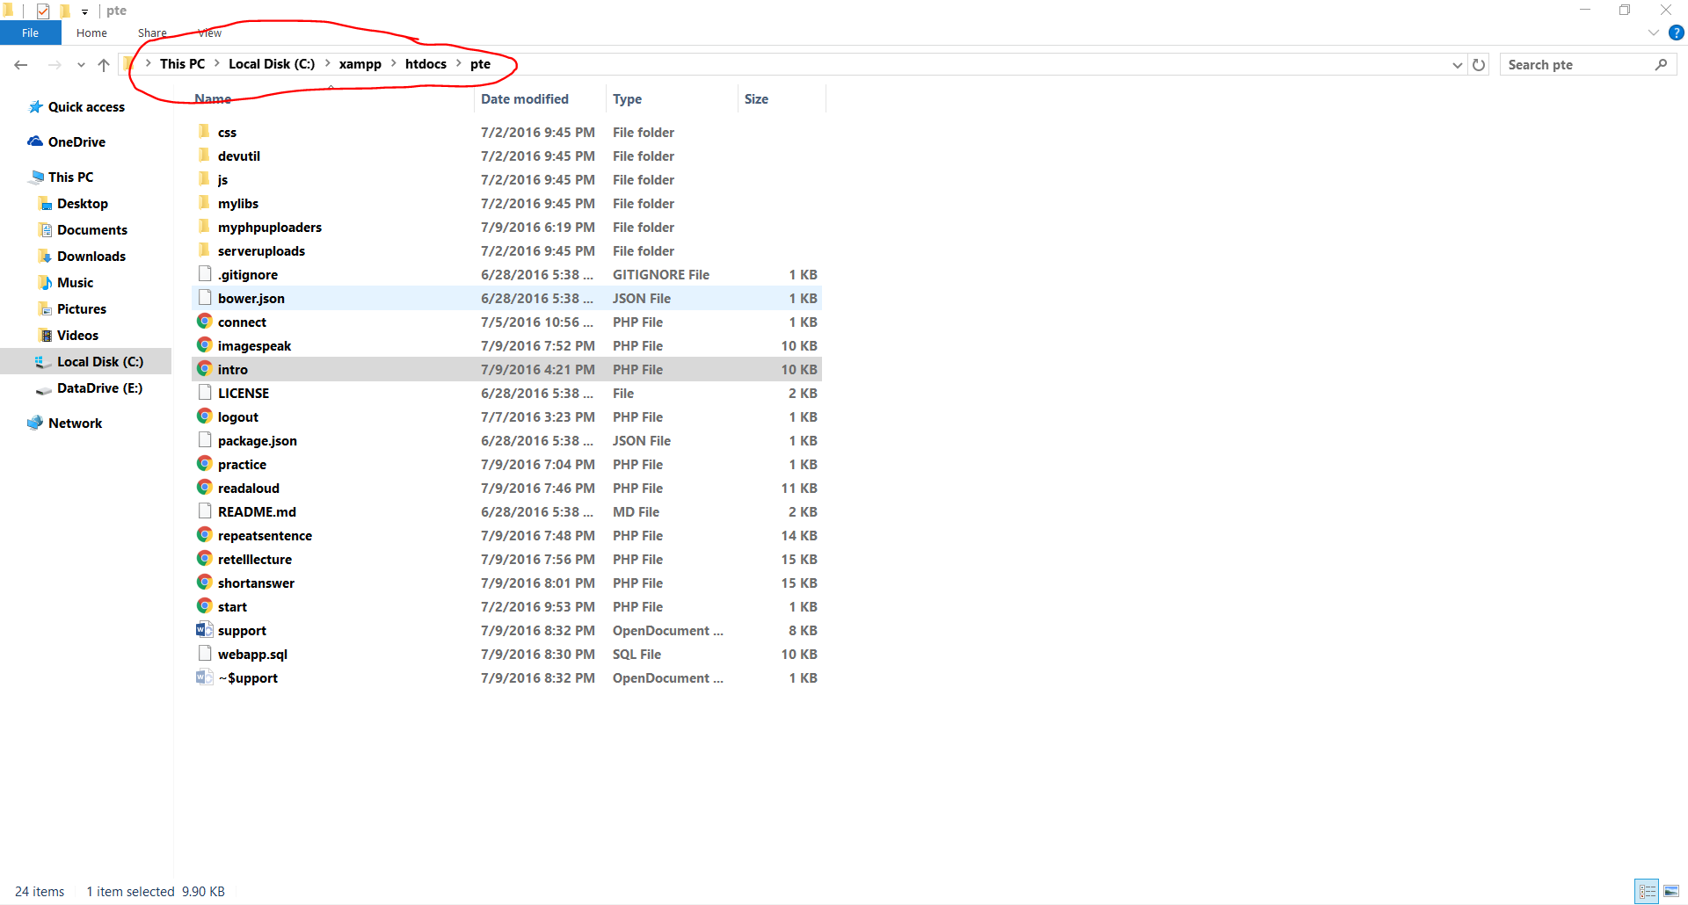

Step 2

Include required javascript files.
Each of the 6 files mentioned in step 2 requires its personal xxxxxrecordmp3.js file to be included. So this makes 6 js files which I have put in mylibs folder. Like below
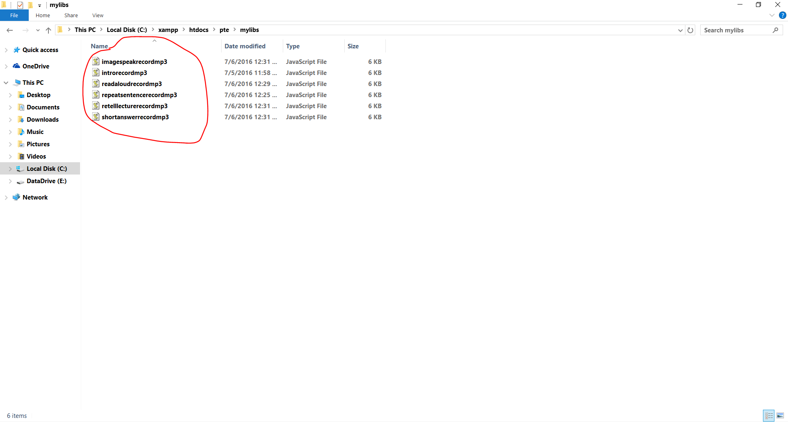

For example (In intro.php)

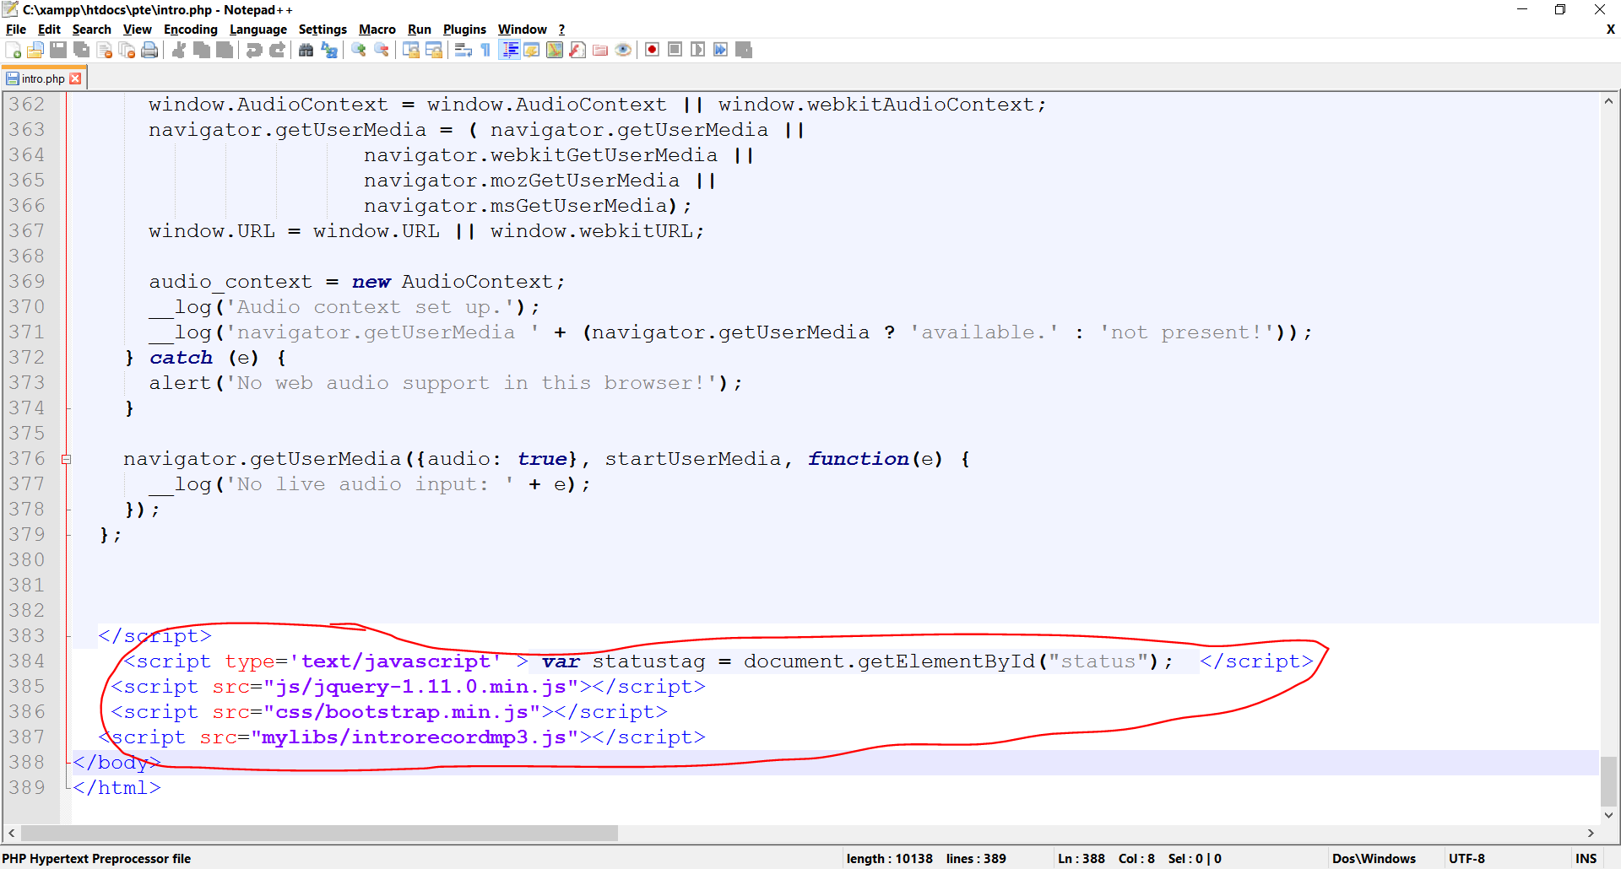

If you want to use recorder and play back in file let say dummy.php.
First you put that file where intro.php and rest of 5 files are.
Then go to mylibs and copy any xxxxxrecordmp3.js file and rename it to dummyrecordmp3.js.
Then open dummy.php and include <script src=”mylibs/dummyrecordmp3.js”></script>

Step 3 (Necessary changes in dummyrecordmp3.js)

Once you include dummyrecordmp3.js in dummy.js open dummyrecordmp3.js. Now in this js file you can specify your phpuploader(which tells the server where to keep the uploaded files on server).
All phpuploaders are in myphpuploaders folder. You will make your phpuploader here (or copy anyone of these and rename it to dummyphpuploader.php)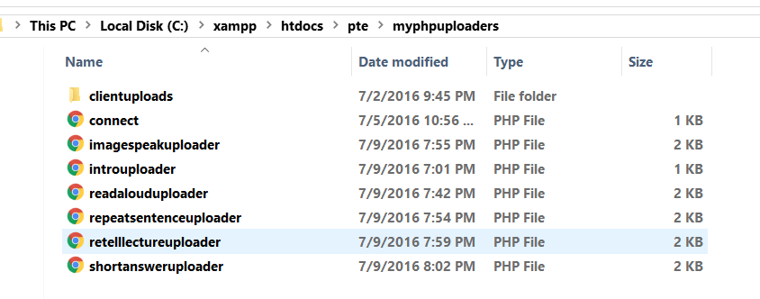
Include dummyphpuploader.php in dummyrecordmp3.js as below:-
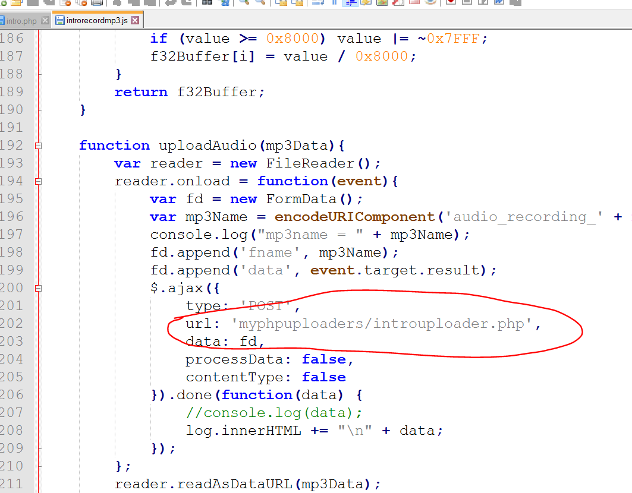

Change URL to ‘myphpuploader/dummymp3uploader.php’ or anywhere your uploader is.

Step 4 (Specifying path in phpuploader)

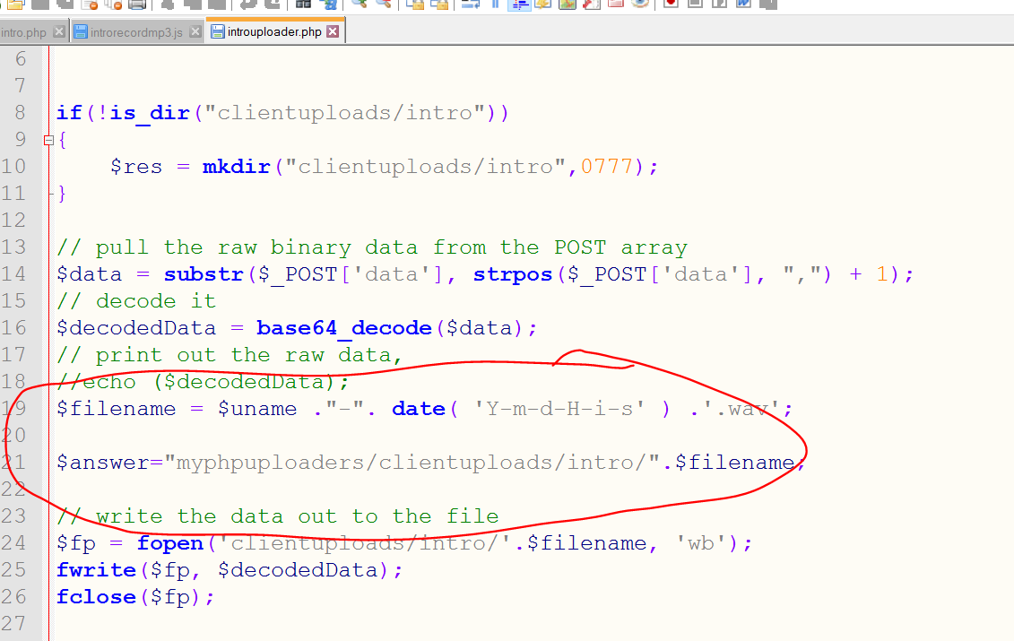

By changing the code in circle you can specify the path and even the file name of the file to be uploaded on server.

Uptill now you have correctly made and altered following
- dummy.php (or the file you want to embed recorder and playback in)
- dummyrecordmp3.php (or the file in which you will specify your uploader)
- dummyphpuploader.php(or the file in which you can specify the filename and path of the file to be uploaded)

Step 5 (Calling functions) (Now Actually Embedding Recorder)

For this I would again use intro.php for illustration.

This code below setups you recorder. So first do this in you file like I did it in intro.php
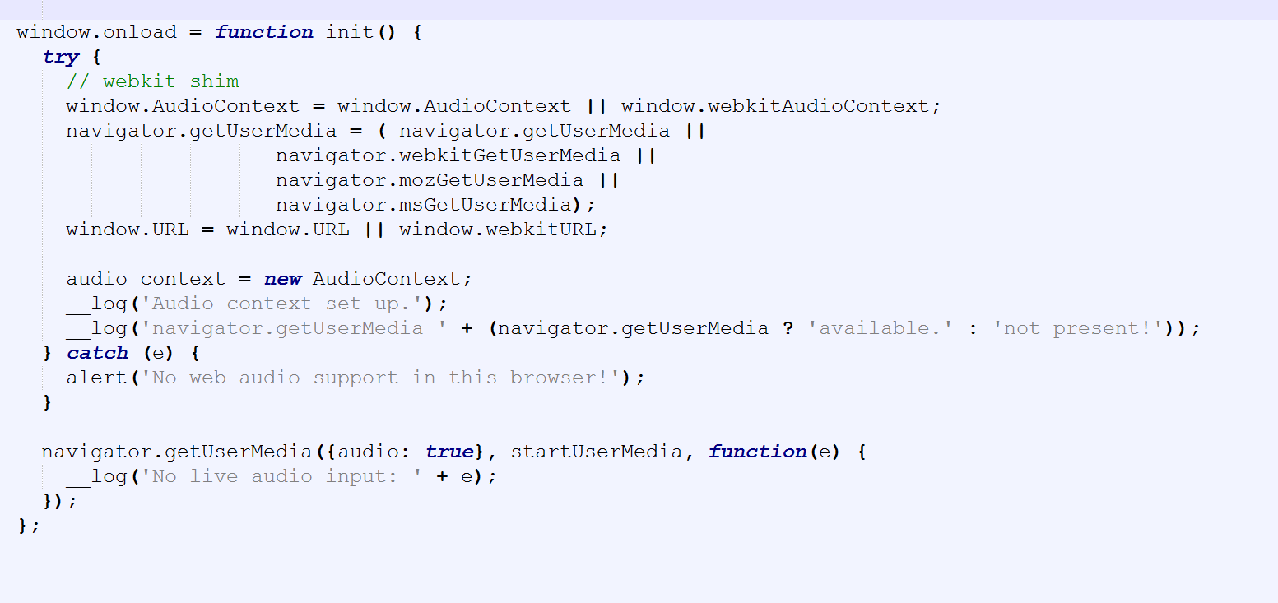
And this
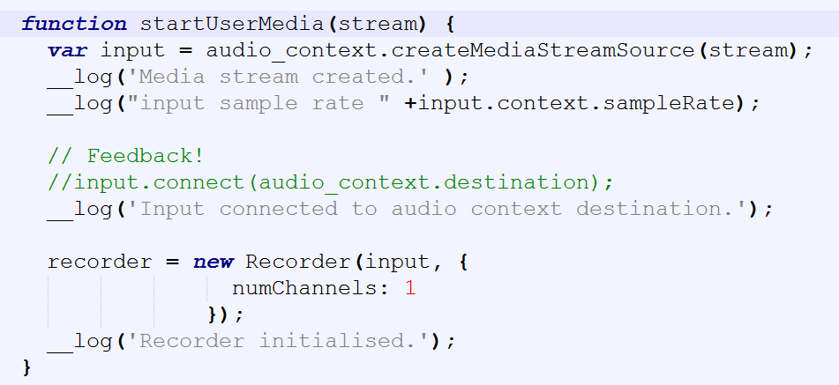

This will setup audio context.

Now After audio context have been setup, you have to implement three functions below like I did in intro.php (Everything is good. You can directly copy/paste)
- StartRecording()
- StopRecording()
- CreateDownloadLink()

- StartRecording starts the recording.
- StopRecording stops the recording.
- CreateDownloadLink is automatically called by StopRecording to upload the audio on server once recording is stoped by StopRecording function itself.

Technique: Use a button on clicking which calls the StartRecording. After certain time(preparetime)(use settimeout function) StopRecording function is called. StopRecording itself calls CreateDownloadLink.

That’s how you embed Recorder in dummy.php(your file).

Step 5 (Calling functions) (Embedding Audio Playback)

That’s simple. It has nothing to do with the APIs.

Audio audio=new Audio(); //makes an audio object
audio.src=””; //specify the audio path to .wav or .mp3 file
audio.play(); // play that audio

How do I link the various parameters such as ‘beginning in’ and ‘time elapsed’ to my tables?

Beginnin in = PrepareTime
TimeElapsed= RecordingTime

I am controlling both of these parameters by table. Like for preparetime and recording time of readaloud.php I am doing sql as below 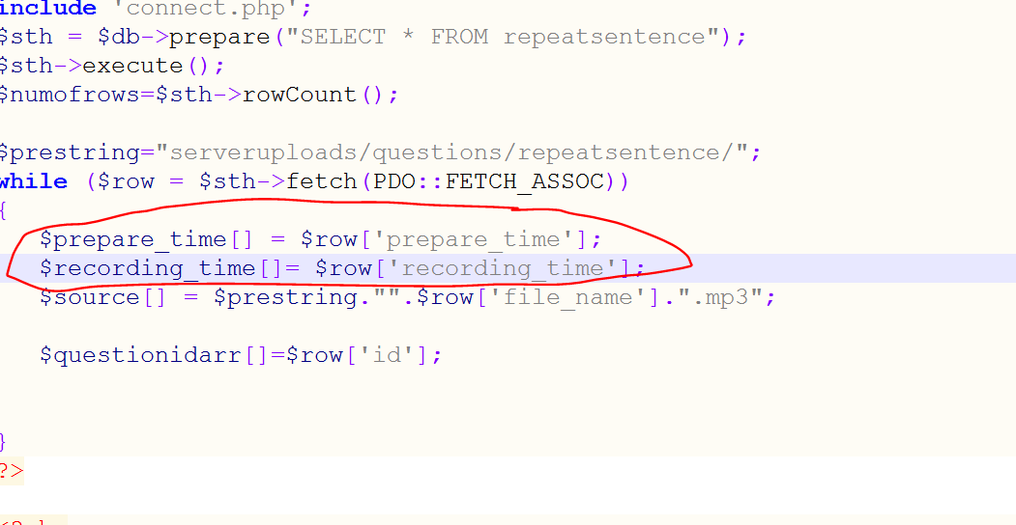

That’s how you will pick preparetime(beginning in ) and recordingtime(elapsedtime) from any table you want to pick.

----------------------------------------------------------------------------------------------------------------------------

